Manny Carrillo

HST 643-44605

Arizona State

History of Tourism

Jul 15, 2023

Escape from COVID: San Antonio to Galveston

 After the travel restrictions were lifted, from March 5th-8th 2021 I took my mom and nieces and nephew to San Antonio, Texas. Going to San Antonio is almost a tradition in my family, we go every year. We always drive down there since it is only about three hours away from our home in Mesquite. We stayed at the Hilton in downtown San Antonio. One of my favorite memories of the trip was swimming in the pool. Now you might be thinking, what’s the big deal? Well, this was a rooftop pool which was not only cool, but the best part was that we had a great view of the Alamo from the rooftop.

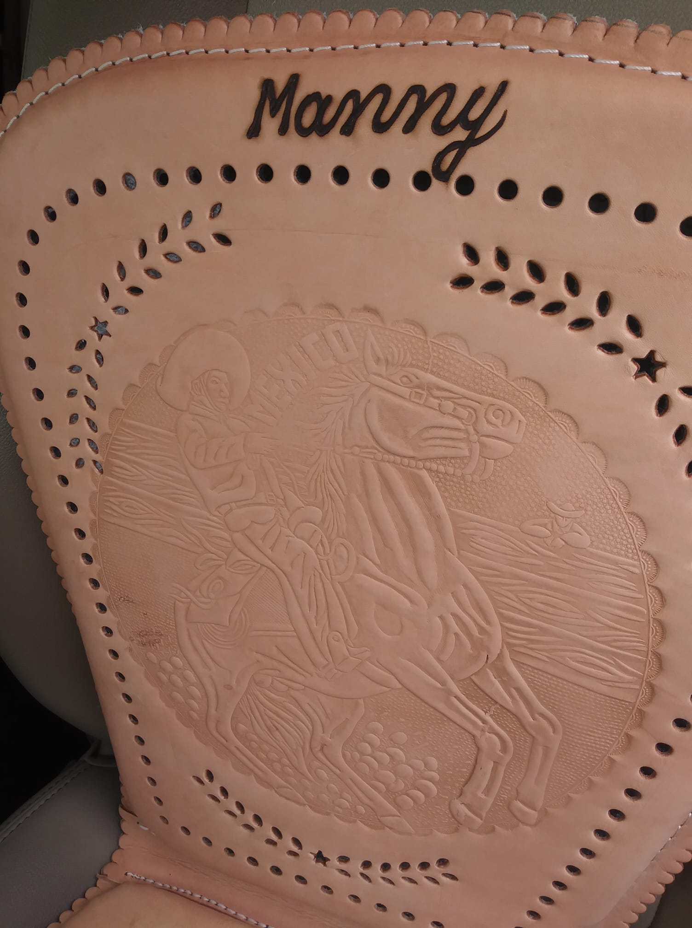 The next day my family and I decided to visit Historic Market Square in San Antonio. We really enjoyed it there as there are many little stores that sell “Mexican goods” such as pottery, leather goods, art, etc. There is also food such as corn in a cup, snow cones (or raspas in Spanish), different flavored waters (mango, pineapple, lemon, horchata), and there are also several Mexican restaurants like *Mí Tierra* for one which is open 24 hours. While I was at the historic market square, I bought 3 leather seat covers, one for me, my dad, and brother-in-law with our names on them. Each had a different design on them, mine had a Mariachi, my dad’s had a bull, and my brother in laws had a Mexican eagle on them. After spending about 3 hours there and after my mom and niece convinced me to buy them rings, we went back to the hotel to rest. Around 7:00 pm that evening we decided to go out to eat. We went to a restaurant called *Pico de Gallo* which we like a lot more than *Mí Tierra*, plus the wait isn’t as long. While we were there, we ordered the fajitas which were very delicious. Afterwards we went back to the hotel and rested before we were to wake up and go back home the next day.

Unfortunately, there were still some COVID restrictions during our trip to San Antonio. For one the hotel did not offer continental breakfast because of COVID restrictions. We also were limited on housekeeping services and were limited on how many towels and toilet paper we could get. Many of the little store fronts and restaurants also required that we wear masks as well and a few store fronts limited the number of people that could be in at a time. So, overall, we spent just a weekend in San Antonio.

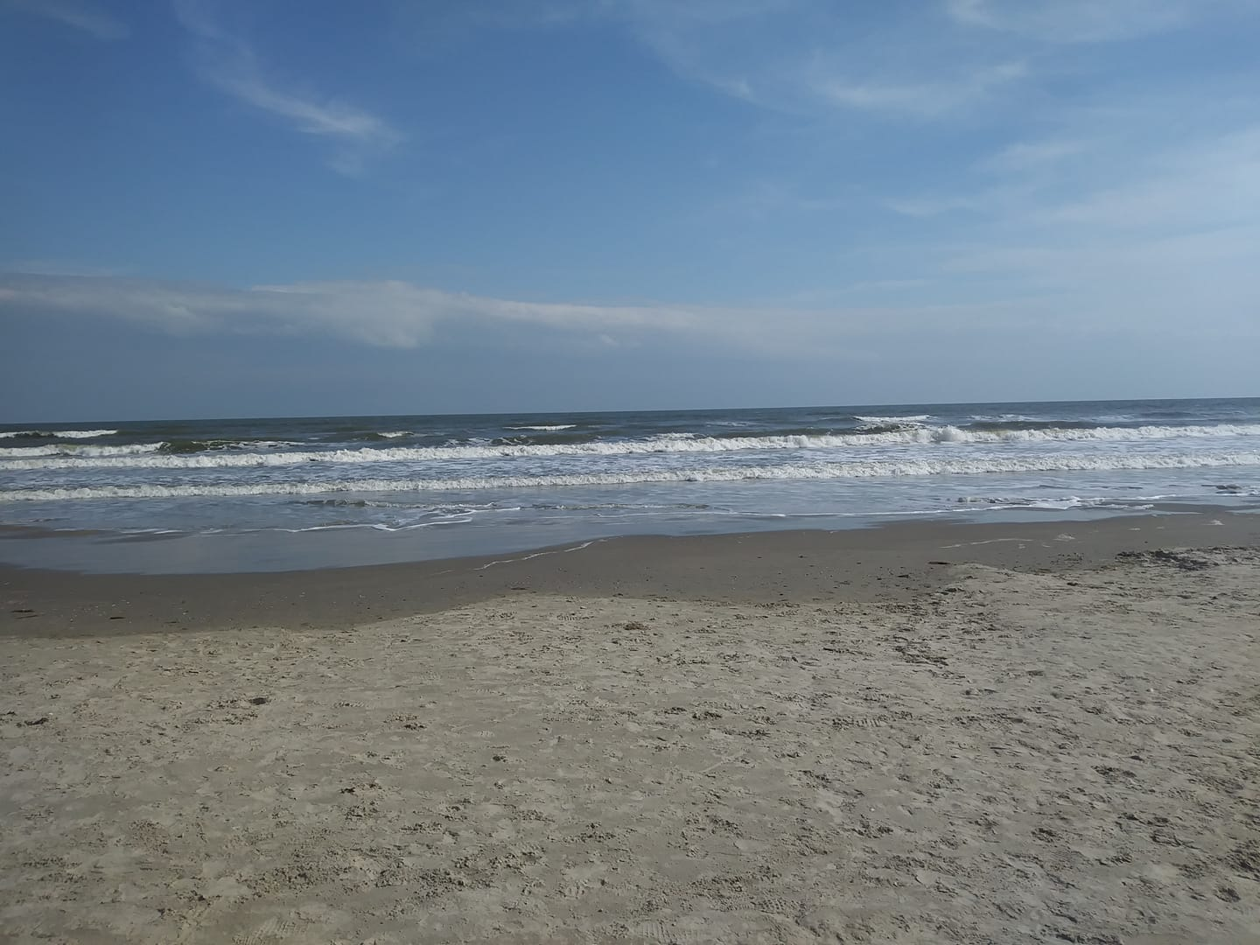 Luckily for me though I was able to enjoy a double vacation. See the school I was working at went on Spring Break from March 9th-13, 2021 and my classes at UNT at the time were all online. So, I decided to plan a trip for myself to go visit Galveston, Texas from 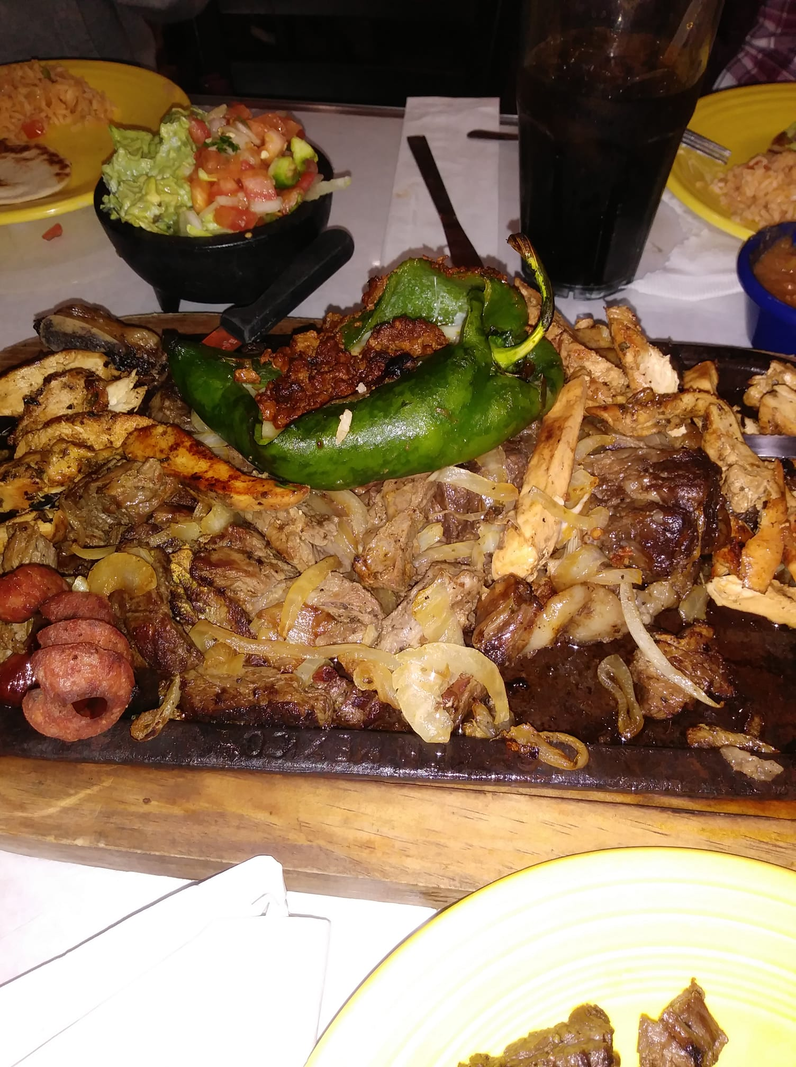March 9th -12th. Galveston is a coastal town and like San Antonio is only three hours away. Like I mentioned before this time I went by myself as I needed to get away and destress from everyone at home and work. Some of my favorite memories of going to Galveston were of course going to the beach, swimming at the pool at the hotel, and getting my first tattoo. The beaches in Galveston are not the prettiest but they will do on a budget. The problem is that during the springtime in Texas it is not the best time to visit the beaches because the water is still freezing cold. Which explained a lot why the beach was practically empty except for a few people. I did not spend much time swimming in the ocean, luckily the pool at the Holiday Inn I was staying at had a heated pool and I really enjoyed that.

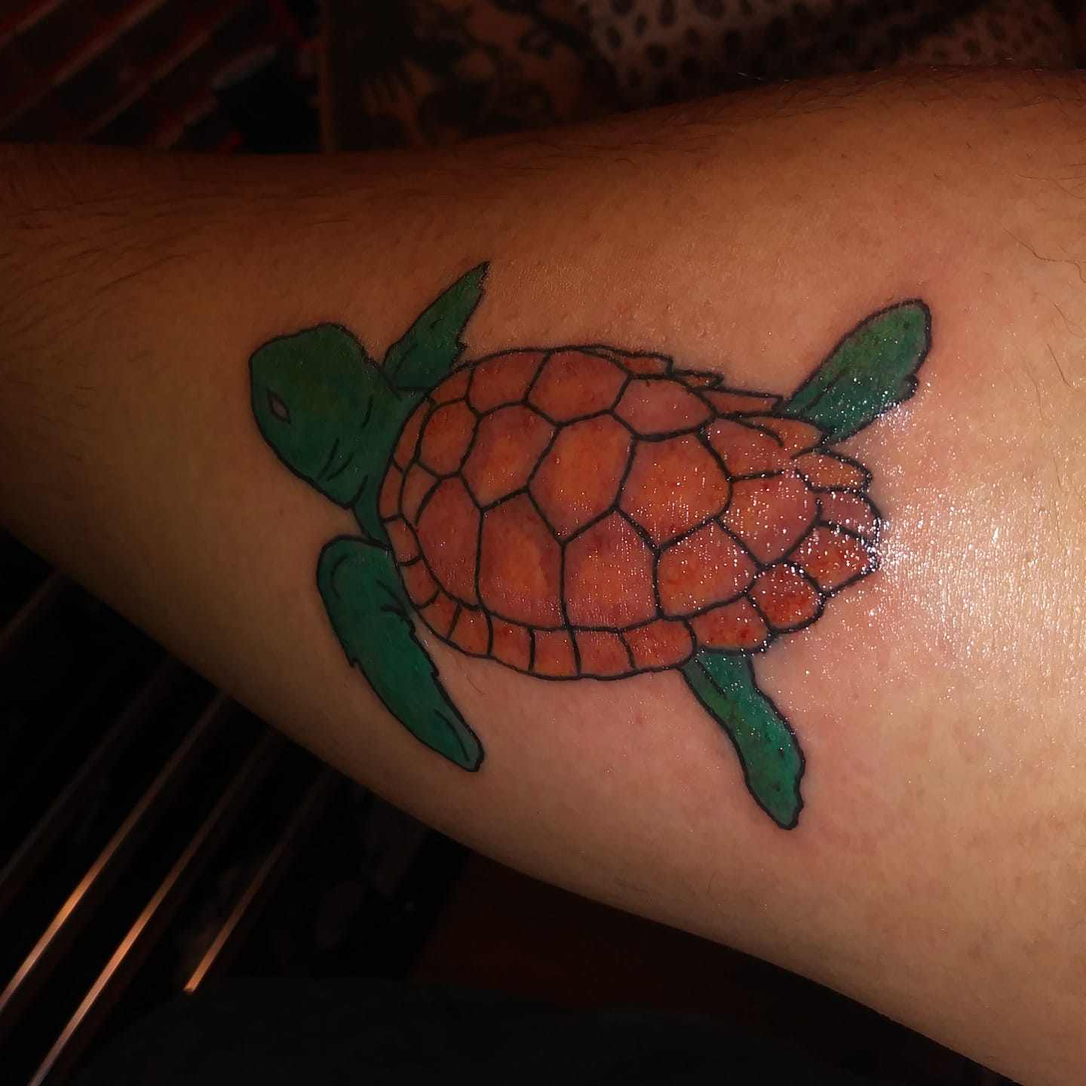 The day before I left Galveston, I got my first tattoo. I had always wanted to get a tattoo but because of not knowing what I wanted and my fear of needles, I was hesitant to get one. It was finally during this trip that I decided to go through with it and get a tattoo. Seeing as I was in a coastal town next to the beach, I decided to get a tattoo of a sea turtle on my right forearm. It also had a significant meaning to me. Sea turtles symbolize change and patience and since I was studying to become a teacher, I decided to get a sea turtle because I would be needing a lot of patience as a middle school teacher. There were still some restrictions in Galveston, such as wearing masks in the hotel, laundromats, stores, tattoo studios, and restaurants. In fact, I recall a gentleman and his wife being asked to leave the laundromat because they would not wear a mask. Also, at the hotel for breakfast while it was a buffet style, we could not handle the food, the hotel staff had to serve us. Those were the only restrictions we had.

COVID was a rough time for everyone, I was in Las Vegas when the pandemic started. So, in a way I started the pandemic on a vacation, and I ended the pandemic by going on vacation as well. Even though the trips I took were just local, it was nice to finally be able to leave your home and enjoy the places that you used to enjoy. It truly did make you appreciate the places and things that you always took for granted.