The West in the face of crises since the nineteenth century
In the West, returning to the land and to locality is one of the traditional responses to crises

Anthony Tchékémian
Maître de conférences en Géographie et Urbanisme (CNU 23-24)
UMR 241 Ecosystèmes Insulaires Océaniens (EIO)
UMR 228 Espace pour le Développement (ESPACE-DEV)
Université de la Polynésie française
Département des Lettres, Langues et Sciences Humaines - UPF
anthony.tchekemian@upf.pf

Biographie
Qualifié en sections 23 et 24, je suis en poste, depuis 2013, à l’Université de la Polynésie Française (UPF) où j’enseigne la géographie humaine, tout en étant rattaché aux Unités Mixtes de Recherches 241 EIO (Tahiti) et 228 Espace-Dev (Avignon). Mon parcours associe les sciences de l'environnement (Bac Professionnel Hygiène et Environnement ; Licence 3 de Biologie des écosystèmes et des populations), l’agriculture (Brevet de Technicien Supérieur Agricole), aménagement et urbanisme (de la L3 au Master 2 Recherche en urbanisme). Ma thèse, soutenue à l’Institut de Géographie Alpine, portait sur un sujet transversal : « les effets de l’application du second pilier de la Politique Agricole Commune, sur les acteurs et les territoires ruraux français ». Ce travail a été récompensé, en 2010, par la Médaille d’argent de l’Académie d'Agriculture de France. Actuellement, je poursuis mes travaux sur le développement des territoires insulaires.
Résumé :
Face à ce qui peut apparaître comme un faisceau de crises globales - sanitaires, environnementales, économiques et même démocratiques - les discours sur les vertus du local et du rural s’imposent, dans les médias comme en politique. Nous proposons de mettre en perspective ce retour au local, d’un point de vue historique. Depuis près de trois-cents ans, les sociétés occidentales ont subi de profondes mutations, notamment économiques, au prix d’une rupture plus ou moins prononcée, et plus ou moins douloureuse, avec la nature. Au cours de notre histoire récente, des voix étonnamment diverses (responsables politiques, artistes, militants...), ont évoqué ce retour à la terre, qui s’est incarné sous de multiples formes. Ce retour apparaît comme une solution providentielle à ces mutations perturbatrices. La crise sanitaire due au Covid 19 semble avoir non seulement confirmé, mais aussi exacerbé cette tendance.

Mots-clés : Agriculture, localisme, écologie, jardins vivriers, crises sanitaires, Covid-19.

Abstract:
Confronted with what may appear to be a series of global crises - health, environmental, economic and even democratic - the ideas on the virtues of what is local and rural are becoming increasingly heard. This article aims at putting this return to locality in historical perspective. For almost three hundred years, Western societies have gone through profound changes, especially economic ones, at the cost of a break with nature, in a more or less dramatic, and more or less painful way. Throughout our recent history, surprisingly diverse voices (political leaders, artists, activists, etc.) have conjured up this return to the land, which has taken on various forms. This return appears to be a providential solution to these disruptive changes. The health crisis due to Covid 19 seems to have not only confirmed, but also exacerbated this trend.
Keywords: Agriculture, localism, ecology, food gardens, health crises, Covid-19.

Introduction
As the coronavirus pandemic continues, we believe we are facing a "new" phenomenon, on an unprecedented scale, since it is unknown, unanticipated, brutal, spreads rapidly, and has disruptive and devastating effects. The polysemous term "crisis" is thus associated with the term "coronavirus" and its collateral effects, whether it be in economic, financial, social, health or even political fields. The word "crisis" comes from the Greek krisis, which refers to separating, the decisive phase of a disease or of making a critical decision. The Greek word then gave the Latin word crisis, then the French "crise". Etymologically, “crisis” implies a revelation that calls for action. A crisis relates to situations 'considered abnormal over a given period of time' and for which “the existing regulatory tools turn out to be inadequate” (TARDY, 2009: 13). It can be sudden and violent, leading to a “break in rhythm or a reversal of trend in some process of evolution” (GEORGES, VERGER, 2006: 104). Moreover, the perception of its brutality can be enhanced by media coverage (ROSSMANN et al., 2018).
The management of the crisis triggered by the coronavirus pandemic (Covid-19) - characterised worldwide by the dramatic drop in production and transport activities, the closure of national borders, the interruption of air traffic and billions of people having to be placed on lockdown – has never been seen before in the history of humankind (NAU, FLAHAULT, 2020). This is a turning point at the beginning of the 21st century. According to economists, "the current health crisis amplifies in an unprecedented way the risks of shortages inherent in the functioning of the Global Value Chains (GVC) that have developed over the last few decades" (FLORENTIN, LAVILLE, 2020). Indeed, the health crisis calls into question the capacity of production systems, particularly the agricultural and industrial systems, to cope with disasters. The protection measures implemented at the state level encourage a return to the local level.
Under the influence of Fernand Braudel, researchers have been able to reject the concepts of specific events or ruptures, and have preferred to observe long-term trends. However, “crisis” retains a heuristic value. Rather than opposing it to continuity, it would be preferable to consider them as complementary (QUETEL, 2020). The post-crisis era is therefore one of change and reproduction. For example, health recommendations are more or less the same across Europe and our current health systems are largely the product of this experience; London has experienced numerous outbreaks of plague, after which barrier measures (such as not shaking hands, kissing, disinfecting mail and coins with vinegar) and protective measures (such as masks) were recommended (BASTIE, 2020; VITTORI, 2020). Confronted with what may appear to be a series of global crises - health, environmental, economic and even democratic - the ideas on the virtues of what is local and rural increasingly spread: permaculture becomes fashionable, wealthy urban dwellers fled to the countryside to spend the lockdown in their second homes, or families consider leaving cities, thereby causing rural real estate prices to soar. However, in times of crisis, returning to locality is not new. This brief historical overview, citing adequate past responses, can then be complemented by other references, sometimes contradictory, but ultimately challenging. In other words, this article aims at putting this return to locality in historical perspective from the eighteenth century, by examining various political, artistic and social expressions of this trend.

1. In France, artists’ reactions to industrialization
From the eighteenth century onwards, French agriculture underwent decisive technical, structural and cultural changes, with, for example, improved tools, the end of fallow land, four-year crop rotation, cereal monoculture, new crops and the specialisation of agricultural areas. However, at the end of the nineteenth and beginning of the twentieth centuries, France was not yet a leading industrial country (in 1945, half of the French were peasants) and there was growing concern about competition from countries like Britain, Germany, the United States and Japan.
Simultaneously, therefore, a vein of institutional agrarianism can be observed in France, with the foundation of the Ministry of Agriculture in 1884 and the defence of small peasant property by the Méline laws. Against a backdrop of economic depression at the end of the nineteenth century (1875-1889), Royalists, Bonapartists and Republicans agreed on the preservation of rural communities in a context of international competition and the "degeneration" of industrial towns seen as hotbeds of social unrest (the Commune of 1871, then the Fourmies shootings on May 1st 1891). These theories were taken up by Marshal Pétain's National Revolution, after the debacle of May-June 1940.
In challenging times, it is always reassuring to look back to some mythologized countryside, some bygone era. The return to the land, in a newly industrialized and modernized world, subjected to economic crises, was already an observable trend among political elites in the nineteenth century. Artists were also sensitive to these developments, Thus, agriculture, a pillar of the French economy, behind that of industry, remained a dominant subject for French artists.
In France, from 1853 onwards, as a reaction to industrialization and academic representations of the ideal landscape, the Barbizon School initiated the first movement for the conservation of nature: its members produced a series of paintings on the Fontainebleau Forest. That wooded area, south east of Paris, thus acquired a historical, cultural and artistic value. This was followed by other "artistic forest series" (an expression used at the time), then by the creation of biological, botanical and hunting forest reserves. For example, one of the founders of this school, the painter Jean-François MILLET, is famous for his rural and realistic scenes with evocative titles: Des glaneuses - Gleaners (1857), L'Angélus - The Angelus (1857-1859), L'Homme à la houe - The Man with the Hoe (1860), Les Planteurs de pommes de terre - The Potato Planters (1861), Bergère avec son troupeau - Shepherdess with her Flock (1863), Le Semeur - The Sower (1865), L'appel des vaches - The Call of the Cows (1872)... These representations were inspired by the artist's childhood. They illustrate ways of life (peacefulness, serenity, harmony, nature) and working conditions in the fields (bending or stooping down, standing up planting, picking), in a world that was still predominantly rural.
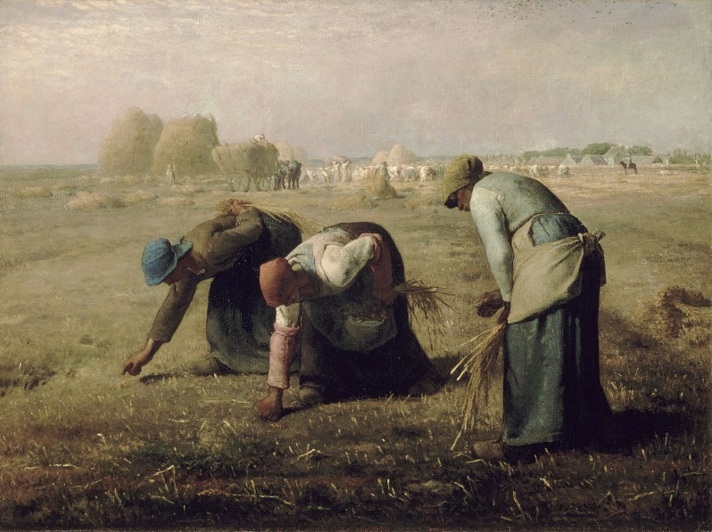
Source: Musée d'Orsay, 2020
Illustration 2: Work by Jean-François Millet, Les Glaneuses (The Gleaners), made in 1857 (oil on canvas, 83.5 × 110 cm, Musée d'Orsay, Paris)
Similarly, the painter Léon-Augustin LHERMITTE was inspired by daily, rural lives. His works, The Harvest (1883), The Gleaners (1887), Friend of the Humble - The Supper at Emmaus (1892), The Harvesters' Pay (1882), depict the lives of characters he saw in his childhood, and highlight the economic difficulties of the peasantry.
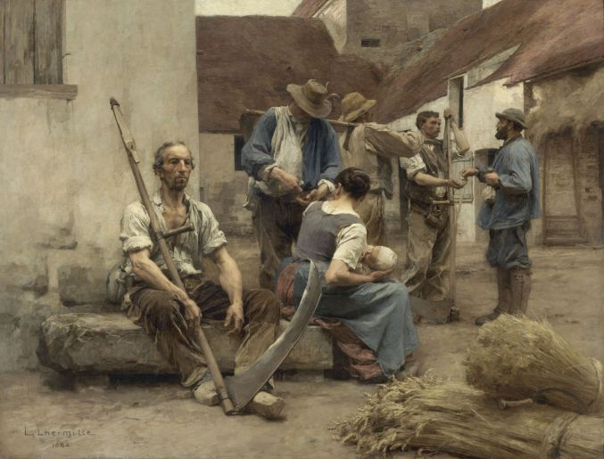
Source: Orsay Museum, 2020
Illustration 3: Work by Léon Lhermitte, La Paye des moissonneurs (The Harvesters' Pay), made in 1882 (oil on canvas, 215 x 272 cm, Musée d'Orsay, Paris)
Thirty years separated these two painters who glorified the aesthetics of peasantry. Jean-François Millet was born in 1814, and died in 1875; Léon Lhermitte was born in 1844, and died in 1925. The two never met, but they chose to represent the rural world. Although Millet remained famous, Lhermitte fell into oblivion. In the continuation of Millet, worthy to be mentioned is the work of Jules Bastien-Lepage, Les foins, (Haymaking) painted in 1877, which depicts the simple yet overburdened life of a couple of peasants, glorifying rest after work in a welcoming natural environment.
At the end of the nineteenth century, the personal relationship to nature was admirably captured by classical impressionists (e.g. Monet, Renoir, Degas...). This French artistic movement expressed the impressions created by objects and light. In The Sower (1888), Vincent Van Gogh expressed the throes of industrial societies by illustrating the dark blue ploughing coming from the horizon with factory chimneys in the background, on the outskirts of the city of Arles. In order to sympathize with the alienation of the poor, he painted the mean earth of the workers' plots.
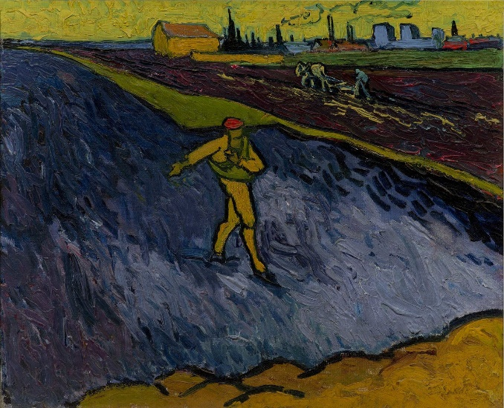
Illustration 4: Work by Vincent Van Gogh, Le semeur (The Sower), made in 1888 (oil on canvas, Hammer Museum, Los Angeles)

2. British aesthetic socialism and garden cities against industrialization
During the Victorian era, Great Britain was the world's leading power and London became the industrial capital of a vast, colonial empire that spanned the globe. The city then appeared as a modern, rich and powerful metropolis. The subsequent expansion of the suburbs was partially offset by the establishment of the metropolitan underground network; the world's first "metro" was inaugurated in London in 1863, and its electrification began in 1890.
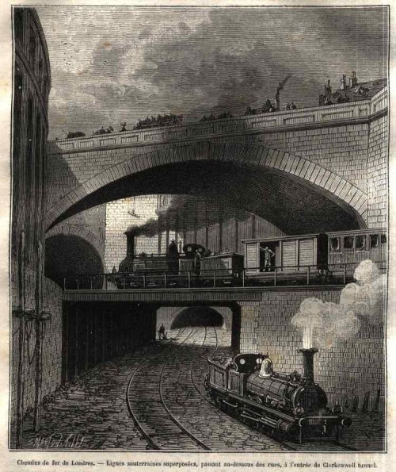
Source: London Transport Museum
Illustration 5: The development of flyover railways in London (Clerkenwell Tunnel entrance, near Ray Street and Farrington Road)
The glorious façade had its downside. Indeed, the English capital became the most populated city in the world, with an impressive demographic growth: almost 1 million inhabitants in 1801, 1.6 million in 1831, 2.4 million in 1851, then 6.7 million at the end of the nineteenth century (BEDARIDA, 1968: 271). Because of overpopulation and industrialization, the authorities feared the return of epidemics similar to the cholera of 1832 which had plunged the British Isles and France into fear. In addition, the Great Stink of 1858 made the government aware of the dreadful sanitary situation. Fear of physical degeneration was then fuelled, in a context of colonial expansion. Consequently, the authorities decided to build sewers in London, which took place on a wide scale between 1859 and 1865. A "sanitary revolution" was under way. (PAPIN, 2005).
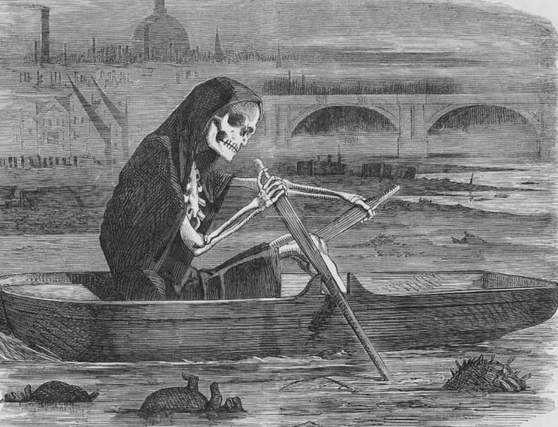
Source: City and Water Blog
Illustration 6: 'Death is rowing on the Thames' (The silent highwayman), caricature in Punch magazine, 10 July 1858 (Vol. 35, p. 137).
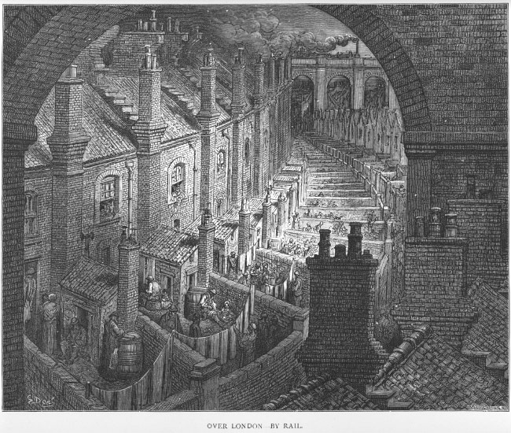
Source: cardiff.ac.uk
Illustration 7: "Above London by train", work by Gustave Doré, one of the painters of the Barbizon School, entitled, in Pélerinage à Londres - Pilgrimage in London (1872), exposing the districts of the East End of London where the poor were crammed together in horrendously unsanitary conditions
Ecological anxiety in the nineteenth century is not to be understood as it is today, but real concerns existed. Our civilisation, marked by the Industrial Revolution that began in England in the eighteenth century, with the development of the steam engine and the use of coal, went hand in hand with the drift from the land and unplanned urbanisation. In this context, and while Marxism put forward a critique of class relations in the industrial society, utopian thinkers, writers and artists suggested a counter-model, rural and nostalgic, responding to the evils of the industrialization, illustrated by the pollution that followed the development of London. Following Augustus Pugin's reflections on the nobleness of Gothic art and the virtues of natural settings, English artists of the Victorian era united to form the Pre-Raphaelite Brotherhood. Pre-Raphaelism, born in 1848 in the United Kingdom, not only suggested a return to a pictorial form that predated Raphael; it also proposed a return to nature, to the English countryside with its cottages, green meadows and rolling hills. Likewise, it yearned for a return to work on the land, to rural values and to medieval-inspired craftsmanship as opposed to industrial production. This movement had strong Christian overtones. Indeed, Pre-Raphaelites believed that industrial ugliness, as it defiled the land with coal and strained social relations, ran counter to the will of the Creator. They then idealised the Middle Ages as a kind of Golden Age, in which peasant communities lived in harmony with nature, which is sheer fantasy.
Thus, in reaction to the ravages of industrialization, the aesthetic socialism of John Ruskin and William Morris developed, making it possible to "characterise human social life at the time, against economic liberalism and capitalism". William Morris (1834-1896), an artist and socialist activist, one of the precursors of ecology, belonged to this trend. To him, besides its alienating effects on human beings, industrialization brought in its wake pollution and destruction of the environment. His novel News from Nowhere (1890) describes a utopian society that broke free from capitalism after a Marxist revolution. This community now thrives in the countryside, in a healthful environment, with wholesome activities. This makes for healthy and “well-knit” characters. The return to the land is described as utterly beneficial. Still, the importance of pre-Raphaelism, to which Morris was associated, should not be overstated as it remained mainly confined to the educated elite. Moreover, it eventually abandoned its social aspirations and turned back to an idealized medieval age, more chivalrous than artisanal.
The Industrial Revolution brought about a dramatic break from a rural past. In the heart of large cities, natural areas were either a luxury reserved for official buildings and stylish residences, or vast leisure places created to appeal to fee-paying tourists. Moreover, many new parks were created by Victorian municipalities. In the suburbs, gardens surrounded detached or more often semi-detached houses and grew depending on whether the area was residential or not. In the larger suburban belts, they ended up merging with the gardens of the farms bought by city dwellers (BARIDON, 1998). Nature’s progress into the city was strongly linked to industrial development. Machines appeared in everyday life. The trend was perceived as a breakthrough, because it transformed the vision of nature: the first factory chimneys were built in the countryside, railway tracks ran across plains and through hills, night work was carried out thanks to gas light. The history of modern green areas is especially conspicuous in cities because of their role in contemporary urban planning.
From the beginning of the twentieth century, many urban planning principles were developed by planners such as Ebenezer HOWARD (1850-1928). This English socialist is the founder of the garden city movement. That was originally a very precise concept developed at the end of the nineteenth century. The main characteristics of Howard’s scheme were: « (1) the purchase of a large area of agricultural land within a ring fence; (2) the planning of a compact town surrounded by a wide rural belt; (3) the accommodation of residents, industry, and agriculture within the town; (4) the limitation of the extent of the town and prevention of encroachment upon the rural belt; and (5) the natural rise in land values to be used for the town’s own general welfare » (Encyclopedia Britannica). Here is visual representation of the concept, entitled « The three magnets »
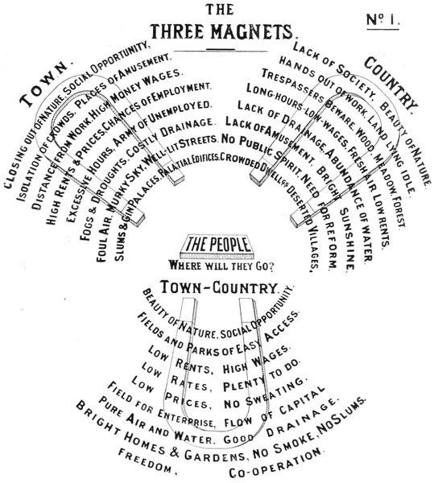
Illustration 8: The Garden City Concept by Howard
Urban reorganization was intended to solve the problems of congested cities caused by the industrial revolution at the end of the nineteenth century. The "garden city" proposed a combination of the advantages of urban and rural life. The first one was created in 1903 in Letchworth. The concept of a Green Belt is a legacy of these principles. It appeared in England first around London following a proposal by the Greater London Regional Planning Committee in 1935. In 1947 the Town and Country Planning Act made it easier for local authorities to integrate such proposals. That meant the creation of undeveloped areas with fields and trees, in order to check the expansion of conurbations. Green belts therefore contain urban sprawl by providing natural spaces close to major cities like London. Subsequently, green belts were consolidated through various measures, with three objectives: slowing down the gradual development of denser urban areas, offering its inhabitants places to relax and maintaining local farming.

3. Nostalgia for working the land
However, while the countryside in the West has gone through profound changes, it has never been completely isolated. Local, regional, national and international trade has always woven its web, and labour migration has brought villages, towns and cities into contact with each other.
In the nineteenth century, in France and England allotments developed as a consequence of the drift from the land and the Industrial Revolution. These small plots were not only a source of additional income, or more precisely a source of food, but above all, they helped to maintain a link with nature in a moralizing perspective, thus warding off some of the consequences of rural exodus. "There was a real paradox, in a context of so-called ultraliberal capitalism based on resources in kind to supplement the structurally low wages applied to a population that had emigrated from the countryside in the first generation: a form of hybridisation based on nostalgic locality and international competition. This has made it possible to maintain connections and identities of terroirs and territories of origin also regarding food trends and heritage in general.". That evolution had already manifested at the end of the nineteenth century, against the backdrop of the Great Depression, which could have been a source of anxiety. Four movements can be highlighted.
The first one grew in France and England. It was oriented towards gardens, as a reaction to industrialization, through workers' housing estates, community life and paternalism. Indeed, it was thought that manual labour would moralise factory workers. In order to keep them busy at weekends, physical and sporting activities were introduced, especially in England. The rationale was that if the workers worked gardens, they would avoid going to the pub to spend their weekly wages, drinking alcohol on Sundays or celebrating "Holy Mondays", which moreover allowed the development of political activities and trade unionism (BECK, 2004). In France, from the Second Empire onwards, such movements were generally initiated by industrialists inspired by Christian principles and the alleged virtues of manual work.
In early twentieth century, some attempts were made to further this popular education. They followed the idea that authentic contact with nature can instil values and characteristics of its own. The virtuous, healthy and redemptive functions of nature can be highlighted (TCHEKEMIAN, 2016: 119): it is an educational space, a school of life and character formation. It is endowed with educational qualities attached to basic principles: rusticity, simple life, learning through tests, absence of a market logic, isolation and distance from the city and the habitual networks of socialisation. This connection with nature makes for the expression of the reflexive and introspective qualities of the individual confronted with his or her own character: for example, by reinforcing values of solidarity when individuals face hardships. In this approach, we find references from the scout movement and Hebertism. Rehabilitation programmes for disoriented or anti-social people were carried out in camps and centres created in fully natural settings.
The second movement, which only concerns France, took place under Marshal Pétain's regime and the national Revolution during the Nazi occupation. The prevailing idea of the Vichy regime was that the defeat of 1940 had been caused by the spirit of self-indulgence and capitalism. The French had become alienated from their national ideology. They had given up on their traditional rustic values, their earthly roots in the land they had always worked, to the benefit of built-up areas. So they were no longer the same French people as before: now they turned to towns to toil and live. These cities were distant from the peasant image and values: they were cosmopolitan, controlled by Jews, Freemasons, preys to financial speculation and Bolshevik agitation. Of course, these ideas were not new at all, but they were systematised by Marshal Pétain.
Indeed, since the nineteenth century, the criticism of stressful conditions caused by industrialization had also led to protectionism, nationalism and antisemitism: these movements were born in the 1880s. Thus, Marshal Pétain recycled these ideas, taking advantage of the defeat of 1940. He himself was the landowner of a vast agricultural estate, the Hermitage, located in Villeneuve-Loubet, and he advocated a return to family and land values, unlike the wandering, stateless Jew "coming from nowhere". The Vichy regime's motto was "Work, Family, Fatherland", stamped on the coins of the time. One of its slogans, "The land will not lie" flourished on propaganda illustrations representing the Marshal alongside peasants.
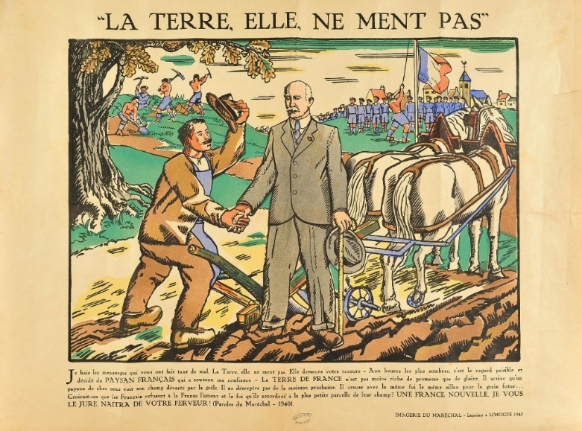
Source: Heritage Libraries (Paris)
Illustration 9: The return to the land advocated by the Vichy regime in the context of the National Revolution (colour print, 37 x 47 cm, Limoges, Imagerie du Maréchal, 1942)
The agricultural sector is one of the major lines of the Vichy regime's policy. It attempted to bring modernity through numerous reforms in a backward-looking and idealised vision of a demographically declining rural world. To turn France around, Marshall Pétain wanted to instil a taste for work and solidarity in young minds and to give them a moral conscience and civic awareness (PECOUT, 2008). To do this, Vichy replaced military service in 1940 with the Chantiers de jeunesse (Working youth organisations), where "a life in contact with nature ensures a moral and virile education". Young people took part in work camps of general interest, serving as labourers in the fields and forests. Not only did they help women farmers, who were often alone on the farms, since the men were prisoners in Germany, but these young men were also to regenerate themselves morally, away from the corrupting cities.
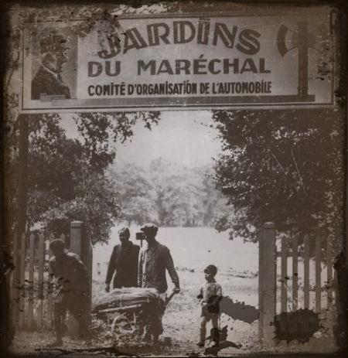
Source: History in question, 2020
Illustration 10: With the "marshal's gardens", which symbolise the motto "Work, Family, Fatherland", Pétain's government advocates a return to the land, despite the absence of the 700,000 peasants prisoners of war.
Between November 1940 and August 1944, the agricultural magazine La Terre française, a weekly devoted to agriculture and rural crafts, and mouthpiece for Pétainist propaganda, was published. This magazine was a means for the Vichy regime to put across its ideas and implement the National Agricultural Revolution. Moreover, in 1942, ecological concerns merged with Pétainism. The French agronomist and ecologist, René Dumont, a pacifist activist who taught at the National Institute of Agriculture, wrote many articles in this agricultural publication associated with Vichy propaganda. Be that as it may, René Dumont became the first green candidate in the 1974 presidential election, at a time when environmental concerns were growing, away from the racialism embodied by the Vichy regime.

Source: Institut National de l'Audiovisuel
Illustration 11: Agronomist René Dumont, green candidate in the 1974 presidential election
The third movement takes us back to the 1960s and 1970s, in Western Europe and the United States, that is the "hippie" counter-culture, and its underlying ecological component. The first theorists of ecology, particularly Germans and Americans, developed the idea that it was necessary to return to things authentic, as the consumer society and the standardisation of lifestyles caused by market capitalism alienated people from their true selves. That economic ideology had created a world where production systems, the economy and the sectors of industry had changed considerably. The tertiary sector, including large supermarkets, had developed, against a backdrop of national and international competition.
Communal life, preferably close to the land, appeared in the wake of the hippie movement. Indeed, more than two thirds of the sixty-nine communities listed in the guide Diggers and Dreamers 96-97: The Guide to Cooperative Living mention an interest in the environment. Thirteen of them make it the main reason for living together. The need for authenticity led many hippies to go back to old farming practices and ways of eating, which partly influenced the movement for the preservation of the plateau of Larzac in 1973. That could also be observed in the emblematic goat breeding in Ardèche from the late 1960s.
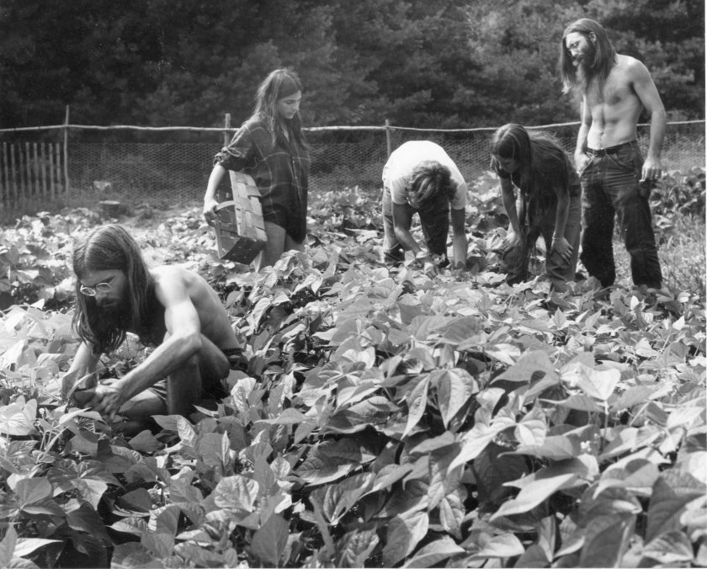
Source: AP Photo/Rebecca Lepkoff collection of the Vermont Historical Society
Illustration 13: Hippies cultivating the land, early seventies, Vermont
The last movement began in the 2000s in Europe, when various alterglobalist groups opposed neoliberal economic globalisation and proposed alternative solutions. This current criticises the concept of 'sustainable development' in particular, opposing it to that of 'sustainable degrowth' (ARIES, 2005; HARRIBEY, 2007; LATOUCHE, 2006). The alterglobalists' message claims to be both a response to the ecological emergency, but also to the crises and excesses of capitalism. The banking and financial crisis of 2008, which began in the United States with the subprime crisis, leading to a real estate crisis and then a worldwide recession, gave a new momentum to the messages of alterglobalists. Since then, the financial, monetary, real estate, energy, food and economic crises have been a reflection of the effects of neoliberalism (MASSIAH, 2010). This last movement is not directly connected to the land. However it aims at promoting more respect for the environment.

4. Small is Beautiful – Private gardens and short circuits
In this context, the idea that the solution was to be found in returning to the local level gathered momentum. This was notably supported by influential French anti-globalisation figures, such as Aurélie Trouvé, an economist and senior lecturer at AgroParisTech, or Pierre Rabhi (1938-2021), essayist, farmer and ecologist that settled in Ardèche, in the South of France. However, the great paradox, accepted by some anti-globalisation activists, rests on the assumption that going back to locality, to traditional crops, would make it possible to limit our impact on the environment; even though it would not necessarily be incompatible with globalised capitalism (GENDRON, 2006; HARRIBEY, 2007). This idea is in keeping with the slogan "Small is Beautiful", chimes in well with the creeds of the advocates of localism, minimalism and 'voluntary simplicity'.
Contemporary French designers and naturalists Simon HUREAU and Fred BERNARD embody this trend. Each authored a book (respectively L'Oasis and Carnet d'un voyageur immobile dans un petit jardin, both published in 2020) on the theme of gardens and nature in the neighbourhood. These spaces have become important for urban dwellers due to the lockdown. The authors advocate a return to one's roots, often to one's native village, by fleeing the city, sometimes along with a career change, by returning to the observation of nature and growing one’s own vegetables. The authors' interest in gardening methods, through organised disorder (English garden type), associating plants supporting each other (kinship and permaculture) deserves our attention for what looks like a phase of withdrawal into residual micro-property. Thus, analysing modalities or combinations of the concept of resilience, i.e. the ability to deal with a risk, a crisis and to adapt to it, is worthy of attention.
One aspect of this trend, exacerbated by the health crisis and the lockdown in spring 2020, has been dubbed “The revenge of the countryside”. In 2020, many well-off city dwellers left cities to spend the lockdown in their second homes in the countryside. Interestingly enough, a similar phenomenon was observed during various epidemics in previous centuries (MEIER, 2020). About 451,000 Parisians are said to have left the capital in March-April 2020. Several factors contributed to the phenomenon: the lockdown, the development of teleworking, but also the wish to reconnect with nature. The attachment of the French to the land, already mentioned, embodied in different ways at different times, seems viscerally steeped in mentalities. Thus, in 1945, a study conducted by the Institut National d'Etudes Démographiques (INED) indicated that 56% of Parisians (and 72% of French people) aspired to live in a house with a garden: "the majority of French people would like to have their own piece of land, cultivate their garden and see their houses stand in the middle of flowerbeds and vegetables, away from the city,” concluded the authors. According to BERNARD (2020) "gardens, culture and nature help to put up with the effects of the current pandemic".
The health crisis had unexpected consequences in this respect: it might have contributed to the development of "organic" food consumption and short circuits (GIRARD, 2020). The advocates of organic farming claim that it can lead to what it now calls "sustainable agriculture". This new type of consumption differs from the model of mass consumption of the Thirty Glorious Years, thus making more room for short circuits, organic food, and e-commerce. These changes had been anticipated by profound socio-cultural changes induced by the rise of environmental concerns and the emerging critique of supermarkets. Crises, like those of the coronavirus pandemic, are amplifiers, accelerators and indicators of pre-existing trends.
Since May 2009, the Ministry of Food, Agriculture and Fisheries has defined the short circuit as a method of marketing agricultural products which is carried out either by direct sale by the producer to the consumer or by indirect sale, provided there is only one middleman. Beyond this reduction in the number of intermediaries, short circuits are now defined by a reduction in the geographical distances separating producers from consumers (HINRICHS, 2000) and by "defensive localism", a form of protectionism (HINRICHS, 2003). Short circuits also cater to consumer demand for authenticity, which is found through direct contact with producers. Sales in short circuits generally concern fruit, vegetables, meat, cheese, bread, wine, honey... These products can be prepared on the farm. Short circuit thus makes for the development of multifunctionality in agriculture.
The consumers' need for reassurance might underlie the revival of short circuits. Successive food crises have led to a lack of confidence in the way food is produced, distributed and marketed. Short circuits make it possible to trace the product, thus increasing the safety and quality of foods still unadultered by processing, transporting and marketing. In this way, organoleptic quality and safety are monitored by drawing up a monitoring sheet identifying products, producers, origins, quality, etc. The origin of the product is put forward as the main argument for trustworthiness. In fact, traceability and origin are nowadays the key words in food reassurance, which corresponds to the demand for healthier products and subsequent local distribution systems. This proximity reassures consumers and products sound more authentic. This includes direct human contact with places, producers, methods (organic, reasoned) and authenticity, even though buying local does not mean buying organic. Furthermore, local consumption both favours fair prices to producers, bypassing supermarkets and their sometimes hefty profits; and, more importantly still, contribute to cutting carbon emissions and thus limiting the ecological footprint of agriculture.

To conclude: degrowth, ecology and the "return to localism" as solutions to crises
A recurring pattern seems to emerge over the last two centuries, marked by modernisation: in times of crisis, reconnecting with the land is promoted as a solution. Agrarianism was encouraged in France as a reaction to the Great Depression, while some aesthetic movements in France and in Britain decried industrialization and, directly or indirectly, praised some return to what is natural. Garden cities belong to this trend. Similarly the downsides of urbanization were partly offset by the creation of various types of gardens and green spaces in populated areas. In the twentieth century, this pattern took on new forms. In France, the Vichy regime tried to instil « peasant nationalism » into the collective mind of the defeated population. After the Second World War, various critiques of the dominant values (mostly capitalistic materialism) emerged with the rise of organic agriculture and the development of closer bonds with nature and with things local. The current pandemic might have reinforced this tendency.
Indeed, theories on the return to "traditional" production modes and more local consumption are widespread nowadays. In times of crisis, self-production and self-consumption appear de facto to be means of fighting against the exhaustion of the planet while questioning unthinking consumption, against a background of global depletion of resources. However, this analysis of the return to locality - informed by historical perspective, empirical methods, ideologies, as seen above - aims at showing that what may look new (epidemics, environmental transformations, etc.) also occurred in the past. Just as in other troubled times, food gardens are now endowed with all imaginable virtues. For example, they could help save money during crises, especially economic crises, sometimes seen as permanent since 2008. The success of Pierre RABHI (2010), who is sometimes branded as an overly backward-looking mystic, is emblematic in this respect.
Whether it be public parks in the industrial era, allotment gardens in the twentieth century, to integration gardens in the 1980s, or collective gardens in the 1990s, the response remains the relationship between culture and nature, and the idea of not severing the crucial bond between man and nature (cf. the programmes of green candidates for elections: concrete and cement must be responded to with trees, so that children can see nature). As shown, the current suggestions to reconnect with locality and the land, as a solution to the global crisis, are not new: they therefore deserve to be deconstructed, analysed and put in a longer perspective. In these times of angst, the theme of returning to the land crops up again and again.
From a resilient perspective, community gardens, for example, certainly appear to be a response to the increase in prices observed since the start of the health crisis. However, before the crisis broke out, these gardens had already been envisioned as a means of providing access to a balanced, healthy and sustainable diet. Subsequently, would-be gardeners find that working the land creates social ties where they live; gardens improve their living environment and offer them an occupation that is experienced as relaxing and reconnecting with the earth. This type of food garden also helps to preserve the links and identities of the territory and terroir of origin with regard to food habits and heritage in general. Over the last twenty years, allotment gardens have been developing in the countryside, in peri-urban areas, possibly in collective self-management. In the end, there is more continuity than discontinuity in these twists and turns of history. A steady pattern, presented as salutary in many respects, emerges: the return to nature, to the land, to locality. This tendency is reassuring during sudden or painful transformations, which often trigger anxiety. It is even more so during abrupt crises.

Bibliography
Articles
BECK R., 2004, « Apogée et déclin de la Saint Lundi dans la France du XIXe siècle », Revue d’histoire du XIXe siècle, n°29, pp. 153-171.
BEDARIDA F., 1968, « Londres au milieu du XIXe siècle : une analyse de structure sociale », Annales. Economies, sociétés, civilisations, 23e année, n°2, p. 269, pp. 268-295, [URL: https://doi.org/10.3406/ahess.1968.421909], accessed on 2 July 2020.
CLEMENT A., 2004, « Régulation économique et sociale et libéralisme mondial dans l'Angleterre de la première moitié du XIXe siècle : les corn laws en débat », Cahiers économiques de Bruxelles, Vol. 47, n°2, pp. 215-248.
DUMONT, 1942, La Terre Française, "La récolte et la conservation des fourrages", conclusion of the article dated 30 May. article of 21 August 1943, 18 September 1943.
Encyclopedia Britannica. « Garden city », [https://www.britannica.com/topic/garden-city-urban-planning], accessed on 9 January 2022.
GARDON S., LENSEL B. (dir.), Le vivant en ville, nouvelles émergences. Gouvernance, intensité urbaine, agriculture et animalité urbaines, Ed. Grand Lyon La Métropole, ACSPAVE, Ecole Nationale des Services Vétérinaires, VetAgro Sup, DDUCV, DPPA, juillet 2016, pp. 112-121.
HARRIBEY J.-M., 2007, « Les théories de la décroissance : enjeux et limites », Cahiers Français, « Développement et environnement », n°337, mars-avril, pp 30-36.
HINRICHS C. C., 2000, "Embeddedness and local food systems: notes on two types of direct agricultural market", Journal of Rural Studies, Vol. 16, n°3, July 2000, pp. 295-303, [URL: https://www.sciencedirect.com/science/article/pii/S0743016799000637], accessed on 16 December 2020.
HINRICHS C. C., 2003, "The Practice and Politics of Food System Localization", Journal of Rural Studies, January 2003, n°1, vol. 19, pp. 33-45, [URL: https://www.sciencedirect.com/science/article/pii/S0743016702000402], accessed on 16 December 2020.
JOUSSE E., 2011, « Chronique d’un non-lieu : le marxisme en Grande-Bretagne », Cahiers d’histoire. Revue d’histoire critique, n°114, mis en ligne le 1er janvier 2014, [URL : http://journals.openedition.org/chrhc/2224], consulté le 22 décembre 2021.
LE CROM J.-P., 2009, « Droit de Vichy ou droit sous Vichy ? Sur l’historiographie de la production du droit en France pendant la Deuxième Guerre mondiale », Histoire@Politique, vol. 9, n°3, pp. 95-108, [URL: https://www.cairn.info/revue-histoire-politique-2009-3-page-95.htm], accessed on 14 July 2020.
LE MAITRON, Dictionnaire biographique version mise en ligne le 15 décembre 2009, [URL : https://maitron.fr/spip.php?article75467], consulté le 22 décembre 2021.
MEIER A. C., 2020, “In Epidemics, the Wealthy Have Always Fled”, JSTOR Daily, 2 April 2020, [URL: https://daily.jstor.org/in-epidemics-the-wealthy-have-always-fled/], accessed on 14 September 2021.
MICHEL-GUILLOU E., 2012, « Développement durable et agriculture durable : Appropriation des concepts et expression des résistances », Les cahiers de psychologie politique, n°21, July 2012, [URL: http://lodel.irevues.inist.fr/cahierspsychologiepolitique/index.php?id=2167], accessed on 17 July 2020.
PAPIN D., 2005, “Londres à la lumière d’un géographe libertaire”, Hérodote, n°117, pp. 77-84.
ROSSMANN C., MEYER L., SCHULZ P. J., 2018, "The mediated amplification of a crisis: Communicating the A/H1N1 pandemic in press releases and press coverage in Europe", Risk Analysis, Vol. 38, n°2, février 2018, pp. 357-375, online on 31 May 2017, [URL: https://doi.org/10.1111/risa.12841], accessed on 8 December 2020.
SAULE-SORBE H., 2013, « Peinture d’arbres autour de Barbizon, panthéisme romantique et photogénie de la forêt », in La forêt romantique, CAILLET V. (dir.), Ed. Presses Universitaires de Bordeaux, Coll. Eidôlon, n°103, pp. 217-235.
TCHEKEMIAN A., 2016, « La nature de la ville. Les représentations sociales des éléments de nature à Grenoble et leurs usages par les institutions d’aménagement et d’animations », in DARRIBEHAUDE F.,
YOUNG CHOI T., 2001, "Writing the Victorian city: discourses of risk, connection, and inevitability", Victorian Studies, n°43, pp. 561-589.

Books
AGHULON M., 1989, Marianne au pouvoir, L'imagerie et la symbolique républicaine de 1880 à 1914, Ed. Flammarion, Paris, 449 p.
ARIES P., 2005, Décroissance ou barbarie, Ed. Golias, Villeurbanne, 162 p.
BARIDON M., 1998, Les jardins. Paysagistes - Jardiniers - Poètes. Ed. Robert Laffont, Paris, pp. 939-1187.
BERNARD F., 2020, Carnet d’un voyageur immobile dans un petit jardin, Ed. Albin Michel, 216 p.
BRAUDEL F., 1992, L'identité de la France, Paris, Arthaud, 221 p.
BRINBAUM P., 1998, Le moment Antisémite, Un tour de France en 1898, Ed. Fayard, Paris, 400 p.
D'ERM, P., 2019, Natura. Pourquoi la nature nous soigne... et nous rend plus heureux. Ed. Les Liens Qui Libèrent, Paris, 224 p.
Diggers and Dreamers Publications (Collective work), 1995, Diggers and Dreamers 96-97: The Guide to Cooperative Living. Winslow, Buckinghamshire: Diggers and Dreamers Publications, 224p.
DORNEL L., 2004, Socio-histoire de la xénophobie (1870-1914), Ed. Hachette Littérature, Paris, 364 p.
FRESSOZ J.-B., LOCHER F., 2020, Les Révoltes du ciel. Une histoire du changement climatique XVe-XXe siècle, Ed. Seuil, Coll. L’univers historique, 320 p.
GENDRON C., 2006, Le développement durable comme compromis. La modernisation écologique de l’économie à l’ère de la mondialisation, Presses de l’Université du Québec, Québec, 294 p.
GEORGE P., VERGER F., 2006, Dictionnaire de la géographie, « Crise », 9ème éd., Ed. Presses universitaires de France, p. 104.
HOWARD E., 2010, To-morrow. A Peaceful Path to Real Reform. Ed. Cambridge University Press, 204 p.
HUREAU S., 2020, L’Oasis, Ed. Dargaud, 116 p.
JOLY B., 2005, Dictionnaire biographique et géographique du nationalisme français (1880-1900), Ed. Champion Seuil, Paris, 704 p.
LATOUCHE S., 2006, Le pari de la décroissance, Ed. Fayard, Paris, 302 p.
MORRIS W., 1890, News from Nowhere, or an Epoch of Rest, Ed. Create Space Independent Publishing Platform (26 mars 2014), 188 p.
PECOUT C., 2008, « Les chantiers de la jeunesse (1940-1944) : une expérience de service civil obligatoire », Agora débats/jeunesses, vol. 47, n°1, pp. 24-33, [URL: https://www.cairn.info/revue-agora-debats-jeunesses-2008-1-page-24.htm], accessed on 14 July 2020.
RABHI P., 2010, Vers la sobriété heureuse. Paris, Actes Sud. 144 p.
RUSKIN J., 1907, Unto This Last and Other Essays on Art and Political Economy, Ed. J.M. Dent & Sons, London, p. 110.
SCHUMACHER E. F., 1978, Small is Beautiful. Une société à la mesure de l’homme, (1973), Ed. Le Seuil, Coll. Contretemps, Paris, 318 p.
SORLIN P., 1967, La croix et les juifs, 1880 - 1899, contribution à l’histoire de l’antisémitisme contemporain, Ed. Grasset, Paris, 345 p.
TARDY T., 2009, Gestion de crise, maintien et consolidation de la paix, Ed. de Boeck Supérieur, Coll. Crisis, 280 p.
TOLKIEN J. R. R., 1937. The Hobbit. Traduction française : 1984, Bilbo le hobbit, Ed. J’ai lu, coll. Science-Fiction, 384 p.
VERDES LEROUX J., 1969, Scandales financiers et antisémitisme catholique. Le krach de l'Union catholique, Ed. Centurion, Paris, 256 p.

Press articles
BASTIE E., 2020, « Peut-on comparer le coronavirus et la grippe espagnole ? », Le Figaro, online on 15 March 2020, [URL: https://www.lefigaro.fr/vox/societe/peut-on-comparer-le-coronavirus-et-la-grippe-espagnole-20200315], accessed on 7 December 2020.
BRET S, 2020, "Covid-19: A Look Back From 2025. In which the coronavirus has changed almost everything", The New York Times, "Opinion", online 3 April 2020, [URL: https://www.nytimes.com/2020/04/03/opinion/coronavirus-future.html], accessed 21 July 2020.
BREVILLE B. Le Monde Diplomatique, “La revanche des campagnes”. December 2020.
FLORENTIN A., LAVILLE E., 2020, « La crise sanitaire nous invite à nous interroger sur la capacité de nos systèmes de production à faire face aux aléas », Le Monde, online on 22 May 2020, [URL: https://www.lemonde.fr/idees/article/2020/05/22/la-crise-sanitaire-nous-invite-a-nous-interroger-sur-la-capacite-de-nos-systemes-de-production-a-faire-face-aux-aleas_6040451_3232.html], accessed on 21 July 2020.
GASIGLIA S., "Le "terrain" Pétain à Villeneuve-Loubet vendu en 2013 par l'Etat ", Nice-Matin, 15 September 2012, [URL: https://www.nicematin.com/faits-divers/le-terrain-petain-a-villeneuve-loubet-vendu-en-2013-par-l-etat-363883], accessed on 14 July 2020.
Nice Rendez-Vous, 16 November 2012, "Villeneuve Loubet près de Nice veut récupérer le domaine de Pétain loi SRU", [URL: https://www.nicerendezvous.com/2012111610681/villeneuve-loubet-nice-veut-recuperer-domaine-petain-loi-sru.html], accessed on 14 July 2020.
VITTORI J.-M., 2020, « Grippe espagnole et Covid-19, deux épidémies étrangement proches », Les Echos, « Analyse », online on 29 April 2020, [URL: https://www.lesechos.fr/idees-debats/editos-analyses/grippe-espagnole-et-covid-19-deux-epidemies-etrangement-proches-1199124], accessed on 7 December 2020.

Excerpts from blogs and websites
BERTHIER C., 2014, L’évolution de l’imaginaire de l’écologie politique au début du XXIe siècle : la restructuration de l’écologie radicale française autour du mouvement pour la décroissance, thèse de doctorat en Science politique, sous la dir. de Frédéric Lambert, Ecole doctorale Sciences de l’homme, des organisations et de la société (Rennes), en partenariat avec l’Université européenne de Bretagne (PRES) et l’Institut du droit public et de la science politique (Rennes), soutenue à Rennes 1, le 26 septembre 2014, 627 p., [URL: https://ged.univ-rennes1.fr/nuxeo/site/esupversions/0694b5db-595c-4055-9ed0-aa20c894816e?inline], accessed on 2 July 2020.
BIROS C., 2014, « "Small is beautiful", une idée transgressive dans la communication externe des banques », ILCEA, n°19, online on 27 June 2014, [URL: http://journals.openedition.org/ilcea/2491], accessed on 18 July 2020.
BRINBAUM P., 1998, Le moment Antisémite, Un tour de France en 1898, Ed. Fayard, Paris, 400 p.
CLEMENTIN B., CHEYNE V., "La décroissance soutenable par Bruno Clémentin et Vincent Cheyne", Institute of Economic and Social Studies for Sustainable Degrowth, [URL: http://www.quinoa.be/je-minforme-3/documentation/decroissance/la-decroissance-soutenable-par-bruno-clementin-et-vincent-cheyne/], accessed on 17 July 2020.
Encyclopedia Britannica, « Garden city », [URL: https://www.britannica.com/topic/garden-city-urban-planning], accessed on 9 January 2022.
GIRARD E., 2020, « Quelles évolutions de nos modes de consommation au temps du Coronavirus ? », Cybergeo, « Débats », « Le grand confinement : avant, pendant, et après ? », mis en ligne le 25 mai 2020, [URL: http://journals.openedition.org/cybergeo/34841], consulté le 10 juin 2021.
Herodote website, "11 January 1892. Méline fait voter la loi protectionniste du double tarif", [URL: https://www.herodote.net/almanach-ID-2999.php], accessed on 9 July 2020.
INSEE, « Population présente sur le territoire avant et après le début du confinement : résultats consolidés », 18 mai 2020, [URL: https://www.insee.fr/fr/information/4493611], accessed on 12 September 2021.
IRESMO, 2015, « William Morris ou Le socialisme esthétique comme critique de la modernité », website Institut de Recherche sur les Mouvements sociaux, le 4 janvier 2015, [URL: https://iresmo.jimdofree.com/2015/01/04/william-morris-ou-le-socialisme-esth%C3%A9tique-comme-critique-de-la-modernit%C3%A9/], consulté le 9 décembre 2020.
MASSIAH G., 2010, "10 years on, challenges and proposals for another world". Mouvements website "Le mouvement altermondialiste face à la crise mondiale", [URL: http://mouvements.info/le-mouvement-altermondialiste-face-a-la-crise-globale/], accessed on 17 July 2020.
Ministère de l'Agriculture et de la Pêche, 2009, "Développer les 'circuits courts': Michel Barnier annonce un plan en 14 mesures", Communiqué, put online on 14 April 2009, [URL: https://www.iddlab.org/data/cache/docinput/5/aHR0cDovL2FncmljdWx0dXJlLmdvdXYuZnIvZGV2ZWxvcHBlci1sZXMtY2lyY3VpdHMtY291cnRz/MjQ3], accessed on 16 December 2020.
NAU J.-Y., FLAHAULT A., 2020, « Le coronavirus, sans précédent dans l’histoire des épidémies », Slate, published online on 28 February 2020, [URL: http://www.slate.fr/story/187923/coronavirus-covid-19-epidemie-pandemie-fermeture-frontieres-oms], accessed on 21 July 2020.
Nsalg.org.uk, « Brief history of allotments », [URL: https://www.nsalg.org.uk/allotment-info/brief-history-of-allotments/], accessed on 9 January 2022.
OECD website, "Global Value Chains and Trade", "The Implications of Global Value Chains for Trade Policy", [URL: https://www.oecd.org/fr/echanges/sujets/chaines-de-valeur-mondiales-et-commerce/], accessed on 21 July 2020.

Orsay Museum website, "Le préraphaélisme", [URL: https://www.musee-orsay.fr/fr/collections/bienvenue/actualites/le-preraphaelisme.html], accessed on 13 July 2020.
Politics.co.uk.reference, « Green Belt » [URL : https://www.politics.co.uk/reference/green-belt/], accessed on 9 January 2022.

QUETEL C., 2020, « Coronavirus : "Il y a de grandes similitudes avec l’épidémie de grippe espagnole" », Politique-autrement, mis en ligne le 23 mars 2020, [URL: http://www.politique-autrement.org/IMG/pdf/2_200411.pdf], consulté le 7 décembre 2020.

SORLIN P., 1967, La croix et les juifs, 1880 - 1899, contribution à l’histoire de l’antisémitisme contemporain, Ed. Grasset, Paris, 345 p.
Virtual exhibition, Archives départementales de la Savoie, chapter 6 "La jeunesse française : la tentative d'embrigadement des jeunes', [URL: http://www.savoie-archives.fr/archives73/expo_savoie_des_ombres/pano06/thumb.html], accessed on 14 July 2020.

Personal communication
BACHIMON P., Professor of Geography at the University of Avignon (UMR 228 ESPACE-DEV - Space for Development), June 2020.

It suffices to cite the historic agreement reached by the European Heads of State and Government in July 2020, which intends to create a plan to support their economies hit by the coronavirus health crisis: a 750 billion €, "financed for the first time by a joint loan, and with a budget for the period 2021-2027 of 1,074 billion €" (according to Emmanuel Macron on Twitter). Moreover, "epidemics facilitate the expansion of authoritarianism" (BRET, 2020). The pandemic has provided pretexts for leaders wishing to close their borders: some have imposed severe restrictions on travel abroad, blocking movements of migrants. Demonstrations by oppositions were banned for 'health reasons'. States strictly control information under the pretext of hunting down fake news.
Globalization has led to a fragmentation of value chains. The various design, production and service operations involved in the manufacture of a product may be located over a large number of countries, and the final product may be destined for consumers living across the world. According to the OECD, "70% of today's international trade is [...] based on Global Value Chains (GVC)". See OECD website, "Global Value Chains and Trade", "The Implications of Global Value Chains for Trade Policy", [URL: https://www.oecd.org/fr/echanges/sujets/chaines-de-valeur-mondiales-et-commerce/], accessed on 21 July 2020.
The Méline law of 11 January 1892 aims to protect French peasants from imports of low-priced agricultural products. It brought to a close the episode of free trade inaugurated with the Free Trade Treaty of 1860, but also the Great European Depression (1873-1892). Among other consequences, it was to delay the modernisation of French agriculture for the duration of the Third Republic. The double customs tariff comprised an ordinary rate and a preferential rate for states which granted France equivalent customs advantages. Cf. Herodote website, "11 January 1892. Méline fait voter la loi protectionniste du double tarif", [URL: https://www.herodote.net/almanach-ID-2999.php], accessed on 9 July 2020.
The school is a group of artists based in a few villages on the edge of the Fontainebleau forest, such as Barbizon, Marlotte, Chailly... From 1824 onwards, painters stayed there to carry out studies based on nature, and then met there regularly. This history of landscape painting is half-way between romanticism, where nature supports and protects), and impressionism, where it is the laboratory (SAULE-SORBE, 2013).
In his paintings Léon Lhermitte described the life and characters of his native village of Mont-Saint-Père. Moreover, in the Cabaret, The Harvesters' Pay and The Harvest, he depicted the same characters recognizeable from one painting to another. Cf. Musée d'Orsay website, "Commented works", [URL: https://www.musee-orsay.fr/fr/collections/oeuvres-commentees/recherche/commentaire/commentaire_id/la-paye-des-moissonneurs-297.html?no_cache=1], accessed on 9 July 2020.
From 18 November 2016 to 26 February 2017, for the first time, the Musée des Beaux-Arts in Reims brought the two painters together in a posthumous exhibition entitled "Lhermitte in the wake of Millet?".
The subject of this painting is inspired by a poem, ’Les foins‘ (‘Haymaking’), written in 1878 by André THEURIET, a friend of Bastien-Lepage: "Midday!... the mowed meadows are bathed in light. On a heap of fresh grass as his bed, the mower lies and sleeps with his fists clenched. Seated next to him, the tanned tedder is dreaming, her eyes open, languid and exhilarated by the loving smell from the hay." (LAMBERTI, 1987: 88).
Cf. article entitled "William Morris ou Le socialisme esthétique comme critique de la modernité", published on the website of the Institut de Recherche sur les Mouvements sociaux - IRESMO, 4 January 2015, [URL: https://iresmo.jimdofree.com/2015/01/04/william-morris-ou-le-socialisme-esth%C3%A9tique-comme-critique-de-la-modernit%C3%A9/], accessed on 9 December 2020.
« Green Belt » [URL: https://www.politics.co.uk/reference/green-belt/], accessed on 9 January 2022.
Various forms of what are called today allotment gardens have existed in England since Anglo-Saxon times. The current system has its roots in the nineteenth century. Later, various Acts of Parliament gave it legal substance : 1908, 1919, and above all the Allotments Act of 1925 « which established statutory allotments ». « Brief history of allotments », [URL: https://www.nsalg.org.uk/allotment-info/brief-history-of-allotments/], accessed on 9 January 2022.
BACHIMON P., Professor of Geography at the University of Avignon (UMR 228 ESPACE-DEV - Space for Development), June 2020. Personal communication.
The schemes developed by Robert Owen (1771-1858) are among the best illustrations of this trend. His utopian communities of New Lanark (Scotland) and New Harmony (Indiana, USA), informed by socialism, are concrete examples of his theories. (LE MAITRON, 2009).
This education through sports activities also developed in France, informed both by warlike patriotism and the promotion of gymnastics societies, typical of extreme right-wing organisations. For example, the league of patriots, founded in 1882 by Paul Déroulède, first republican, then staunchly nationalistic.
In France, during the nineteenth century, a habit called Holy Mondays consisted in being off work on the first day of the week. Then, during the first industrialization and the development of work on Sundays, Mondays off became autonomous days gradually used for political and trade union activities (BECK, 2004).
A youth organisation founded in 1907 by Robert Baden-Powell, a serviceman, with the aim of educating morally and civically through community life.
A physical education method instituted in 1907 by the French educator, Georges Hébert, advocating exercise in a natural setting.
Interestingly, sylvotherapy has recently become a field of academic studies. It provides scientific evidence that contact with nature improves not only physical health and psychological well-being, but also cognitive functions. See D'ERM (2019).
About the use of symbols as educational tools to convey ideals, see: AGHULON (1989); on French nationalism (1880-1900): BRAUDEL (1992), JOLY (2005); on antisemitism in the 1880s 1890s SORLIN (1967), BRINBAUM (1998), DORNEL (2004), VERDES LEROUX (1969).
Cf. article published in Nice Rendez-Vous, 16 November 2012, "Villeneuve Loubet près de Nice veut récupérer le domaine de Pétain loi SRU", [URL: https://www.nicerendezvous.com/2012111610681/villeneuve-loubet-nice-veut-recuperer-domaine-petain-loi-sru.html], accessed on 14 July 2020. See also: GASIGLIA S., "Le "terrain" Pétain à Villeneuve-Loubet vendu en 2013 par l'Etat ", Nice-Matin, 15 September 2012, [URL: https://www.nicematin.com/faits-divers/le-terrain-petain-a-villeneuve-loubet-vendu-en-2013-par-l-etat-363883], accessed on 14 July 2020.
The 2 franc coin, from 1943, is an example, with a reverse side bearing the motto "Work, Family, Fatherland" and pubescent oak leaves, then an obverse side bearing the words "French State" and two ears of wheat on either side of a francisque (the double-edged axe used by Frankish warriors and symbol of Marshal Pétain).
In its desire to reform France, the Vichy Regime promulgated no less than 16,786 laws and decrees between July 1940 and August 1944 (LE CROM, 2009: 102).
Cf. virtual exhibition, Archives départementales de la Savoie, chapter 6 "La jeunesse française : la tentative d'embrigadement des jeunes', [URL: http://www.savoie-archives.fr/archives73/expo_savoie_des_ombres/pano06/thumb.html], accessed on 14 July 2020.
The term "oecology" was coined in 1886 by a German biologist and philosopher, Ernst Haeckel, a disciple of Darwin. Later, Haeckel was, along with others, at the origin of so-called "deep ecology": a conservative and conservatory ecology, inherited from nineteenth century German Romanticism and the pagan "Völkisch" movement, placing nature above all else. An immaculate, unchanging, harmonious nature, which must be preserved, protected from the action of man, the disturber in the harmony of creation.
In these articles published in La Terre française..., Dumont gave a modern and productivist approach to agronomy: "German farmers are watching us, let us be proud of our reputation; let us show them a progressive agriculture, up to date with the latest techniques. "DUMONT, 1942, La Terre Française, "La récolte et la conservation des fourrages", conclusion of the article dated 30 May). Then, in other conclusions of articles, he suggested the adoption of social measures: "every agricultural property should grant a plot of land on its own account to each of its permanent employees, allowing them to cultivate it on their free time, with the tools of the farm" (article of 21 August 1943); "the sharecropper must rise to a social level and reach the rank of farmer" (article of 18 September 1943). From July to October 1943, René Dumont was "special envoy" of La Terre Française, for a series of five articles on the south-west. The article of 21 August 1943 is entitled "The situation of the Languedoc vineyards", the article of 18 September 1943 is entitled "The agricultural evolution of the South-West and the obstacle of sharecropping".
Diggers and Dreamers Publications (collectif publication). Diggers and Dreamers 96-97: The Guide to Cooperative Living. Winslow, Buckinghamshire: Diggers and Dreamers Publications, 1995, 224 p.
As a criticism of the western economy in the wake of the first oil crisis, this concept was developed in 1973 by SCHUMACHER (1978). The expression « Small is Beautiful » means "that with fewer material means it is possible for humanity to achieve a qualitatively higher state; [...] that growth in itself should not be a criterion for judging the health of the economic system; [...] that some human problems are best dealt with at the local level and that small organisations, whether they be for profit, political, educational or other purposes, are often more effective than large ones in dealing with human problems"' (BIROS, 2014: 3). The Small is Beautiful creed nowadays is reviving some of the ideas of Thomas Jefferson and other American authors (BERTHIER, 2014: 149). This calls for reflexions on agrarianism.
Idea developed following a discussion with Professor Philippe Bachimon in July 2020.
BREVILLE B. 2020, Le Monde Diplomatique, December 2020.
« Population présente sur le territoire avant et après le début du confinement : résultats consolidés », INSEE, 18 May 2020, www.insee.fr
A similar survey with British people would have probably provided the same results.
Fred Bernard invited on Arte, during the programme "28 minutes", broadcast on 3 July 2020.
Although the term 'sustainable agriculture' did not yet exist in the 1990s, as it emerged in the early 2000s (MICHEL-GUILLOU, 2012).
Direct selling from producers to consumers can take place on farms (basket, picking, market), collective sales (sales point or collective basket), at markets (of local producers), during sales on the road (relay point for delivery) or at home (via the internet), or by pre-organised sales (Associations for the Maintenance of Peasant Agriculture). Indirect selling (with only one middleman) concerns sales to restaurants (traditional, collective), and sales to a retailer (butcher, neighbourhood grocery shop, large and medium-sized stores). Cf. Ministère de l'Agriculture et de la Pêche, 2009, "Développer les 'circuits courts': Michel Barnier annonce un plan en 14 mesures", Communiqué, put online on 14 April 2009, [URL: https://www.iddlab.org/data/cache/docinput/5/aHR0cDovL2FncmljdWx0dXJlLmdvdXYuZnIvZGV2ZWxvcHBlci1sZXMtY2lyY3VpdHMtY291cnRz/MjQ3], accessed on 16 December 2020.

